UCB Flow

1. Company/Client is created from the website or from loops manage page

<https://www.usedcardboardboxes.com/gaylord-buy>

[http://www.usedcardboardboxes.com/ucbloop/manage_supplier_mrg.php?posting=yes&recype=Supplier](http://www.usedcardboardboxes.com/ucbloop/manage_supplier_mrg.php?posting=yes&rec_type=Supplier)

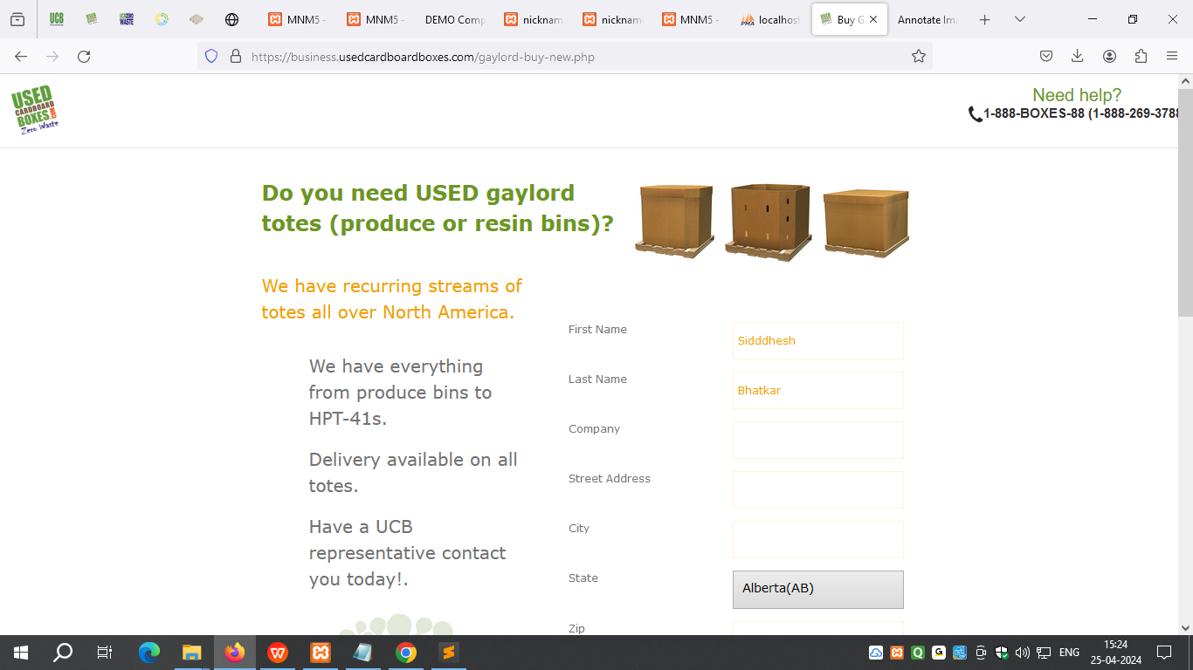

1. UCB representative sends quotes to the client/customer from loop system. Based on the customer need, UCB representative re-quote.

https://loops.usedcardboardboxes.com/viewCompany.php?ID=81689

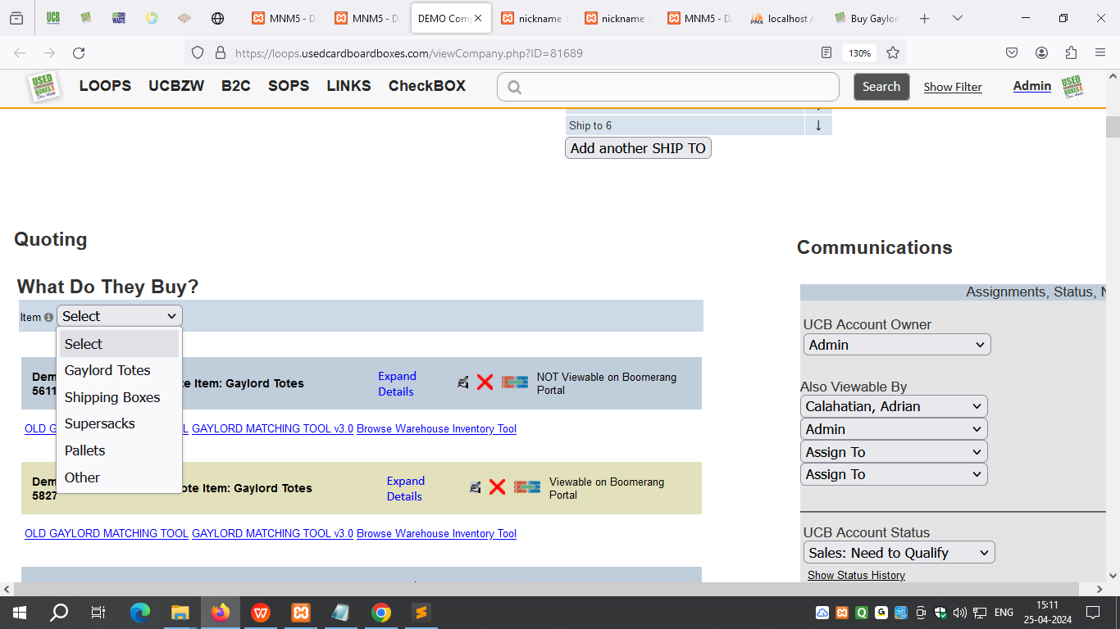

1. All the email is communications are saved in the CRM screen. UCB representative use their own email application to communicate, auto cc is send to single email address.

<http://localhost/ucbloop/viewCompany-purchasing.php?ID=151547&show=transactions&warehouse_id=3652&rec_type=Supplier&proc=View&searchcrit=&id=3652&rec_id=28939&display=buyer_payment>

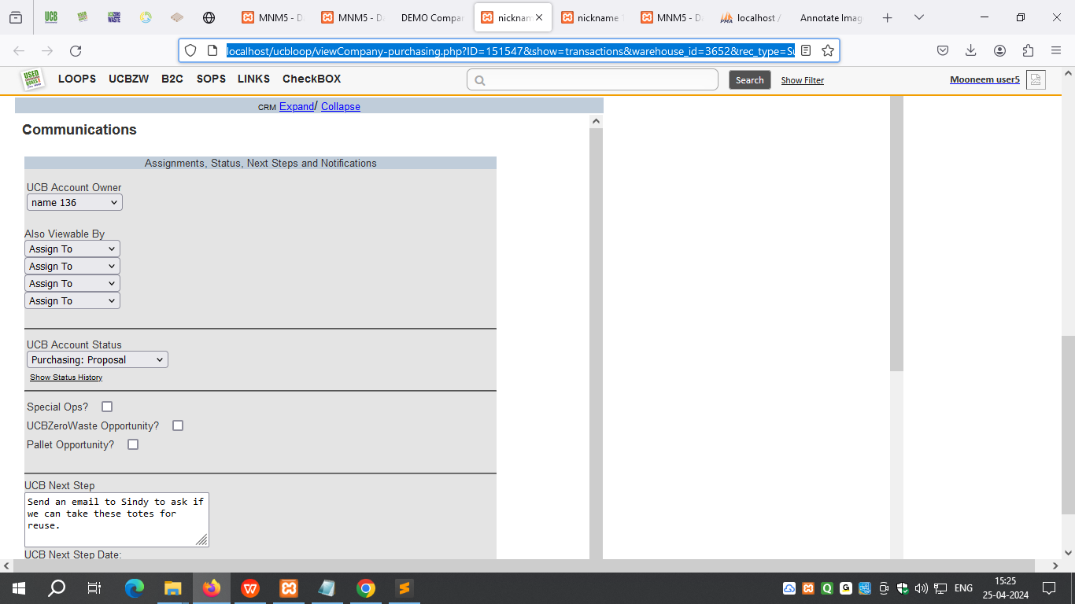

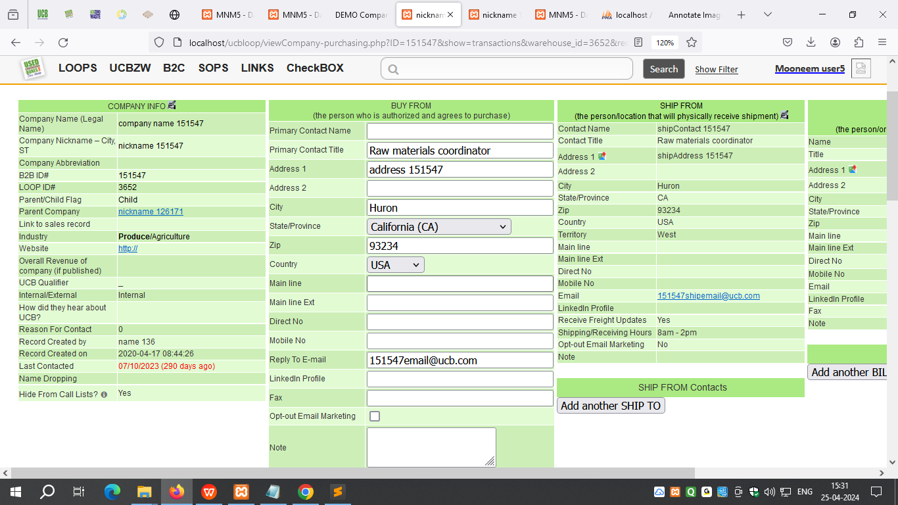

1. Program read from this email and import the email in the specific company. This helps to keep the track of email trails.

1. After the quote is approved by customer, new transaction is created in the loop system. The purchase order is entered, along with the customer name, date, purchase order amount and etc. This turn’s first “Ordered” bubble is half black.

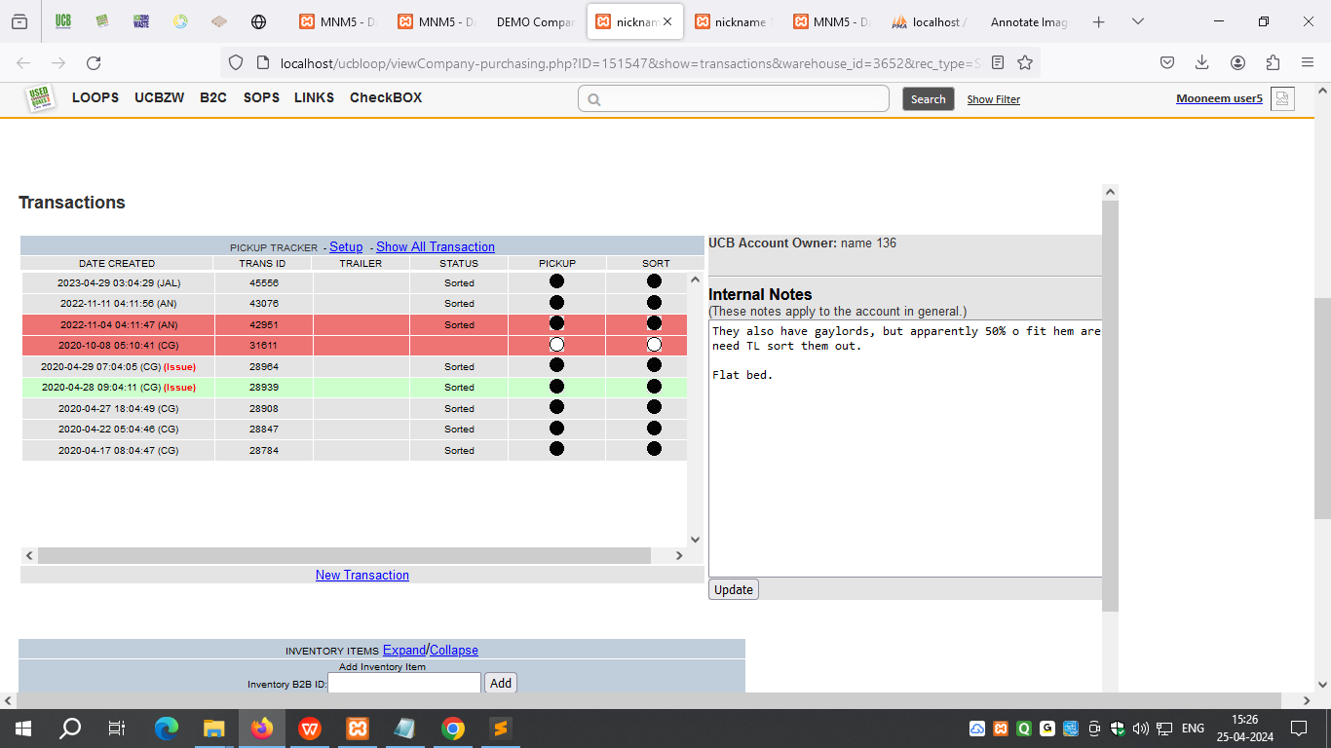

1. After this sales order is entered, box quantity, warehouse details are entered. Notes can be added to the sales order.
2. When the order is ready/good to ship then “Good to Ship” button needs to be clicked. This turns first “Ordered” bubble is turn into full black.

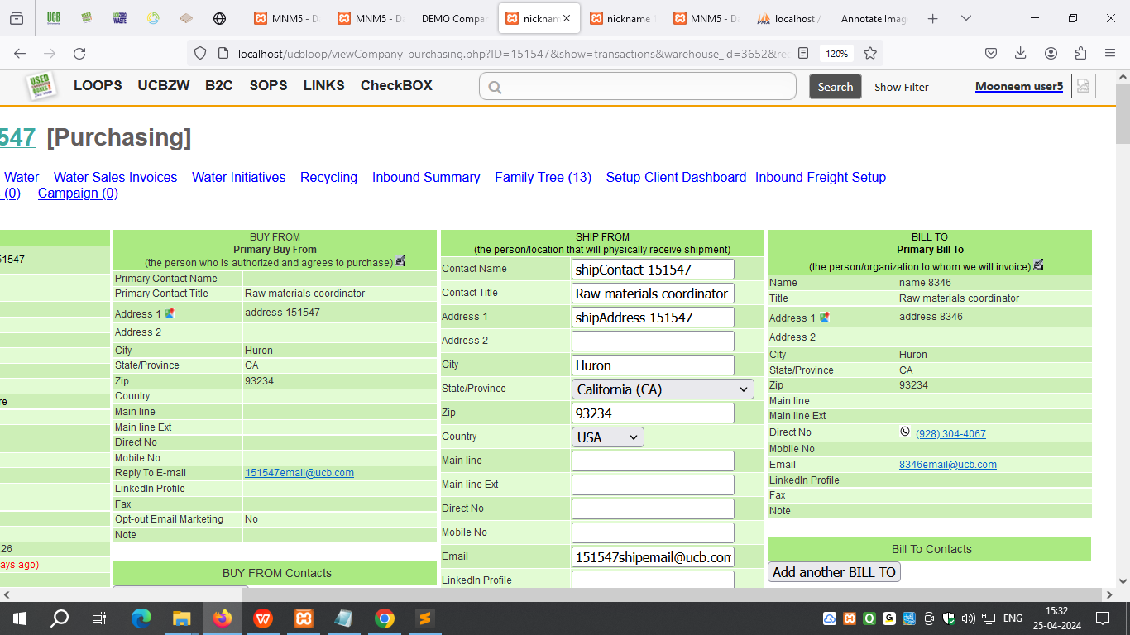

1. After this Freight details need to be updated in the “FREIGHT BOOKING” table, which is present in the second bubble. There they enter the “Freight Company”, “Freight Broker”, “Pickup Date”, “Pickup Time”, “Delivery Date”.

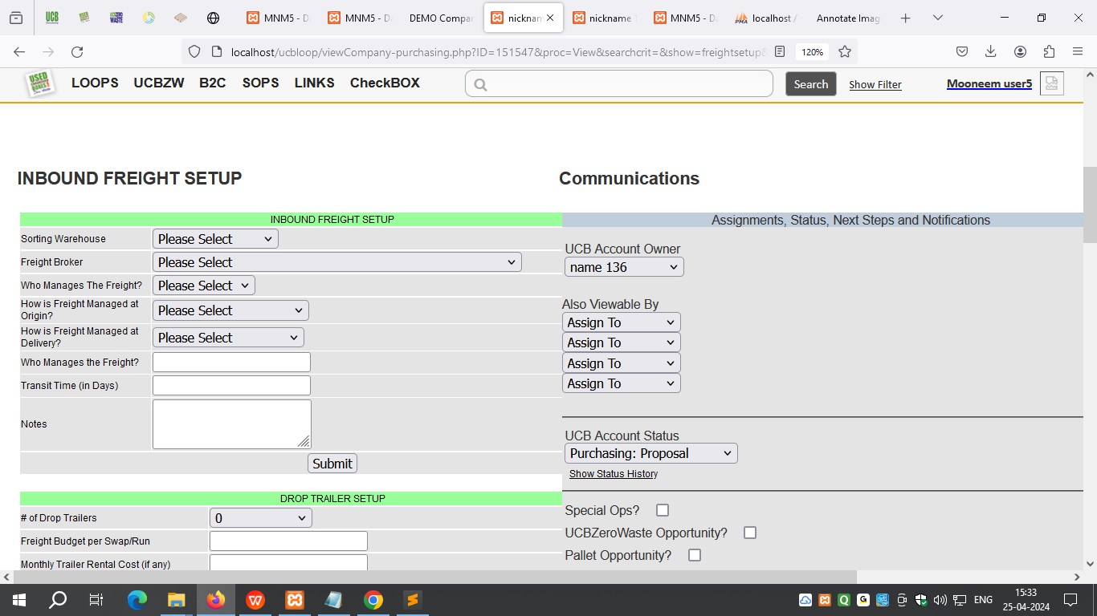

1. In this screen “Sales order” table is shown for reference. After this “CREATE BOL” needs to be entered. In this table, box quantity, pallets details and ship details need to be entered. After this need to click on "SEND TO WAREHOUSE", "BOL RECEIVED @ WAREHOUSE", "SHIPPED" buttons.
2. When clicked on "SHIPPED" button, second bubble “SHIPPED” turn into full black.
3. 
4. After this in the third bubble “Received” screen, need to click on the “RECEIPT CONFIRM” and “B2B SURVEY” buttons. When clicked on the “RECEIPT CONFIRM”, third bubble turns into half black. And after “B2B SURVEY” buttons is clicked then third bubble turns into full black.

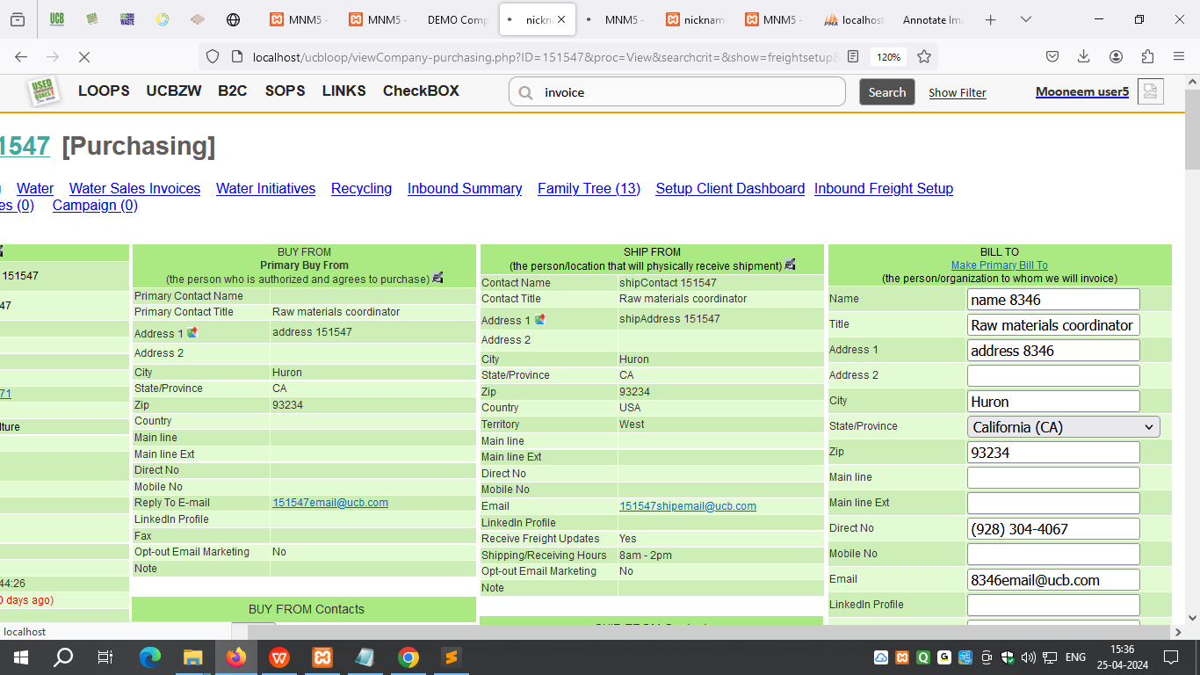

1. After this in the fourth bubble “Paid” screen, email is send to accounting team to enter the invoice in the QB. All the invoice details are stored in the “INVOICE SENT TO ACCOUNTING” table.
2. After the invoice in entered in the QB, newly created invoice number will be entered in the “INVOICE SENT” section. This action turns fourth bubble half black.
3. After this when payment is received for the invoice then it is entered in the Qb and details are updated in the “INVOICE PAID” table. This action turns fourth bubble full black.

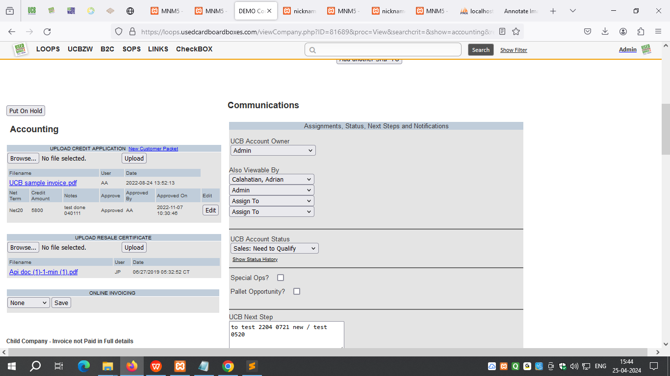

1. After this in the fifth bubble “Vendor” screen, “VENDOR TRANSACTION” needs to be entered. After vendor (freight) entry are added then fifth bubble turns into half black.
2. After all the vendor payments are came and entered in the “VENDOR TRANSACTION” and marked as “Paid” then fifth bubble turns full black.

